**GUJARAT COUNCIL ON SCIENCE AND TECHNOLOGY**

**Dept. of Science and Technology, Govt of Gujarat**

**Technical Report for Level-2 Proof of Concept (PoC) Stage for ROBOFEST-GUJARAT 3.0**

1. **Complete and exhaustive description of all the logical steps in the working of Robot**
2. **Description of Robot:**

This project aims to design and develop a group of aerial vehicles capable of coordinated motion without external controls. The primary objective is to enable the robots to move together in a synchronized manner, maintaining a predefined distance and direction, including forward, backward, left, and right movements over a range of 100 meters.

The system comprises 3 aerial robots, each equipped with flight controllers, communication modules (ESP8266), and control mechanisms. These robots are designed to operate as a unified swarm, with a central control unit acting as the master node responsible for distributing commands and facilitating coordination among the individual robots. The central control unit has Odroid Xu4 as the processor to give commands and take the feedback from the swarm.

To achieve coordinated motion, the robots employ advanced algorithms and techniques which we developed using libraries like drone kit and mavlink. Communication protocols are established to enable information exchange between the robots and the control unit. These protocols facilitate the sharing of positional data, speed, and other relevant parameters necessary for synchronization.

A swarm algorithm is developed to determine the desired direction of motion for the entire swarm. This algorithm takes into account input from the control unit and the feedback received from individual robots, ensuring a consensus on the direction and maintaining synchronization throughout the motion.

The project includes rigorous testing and evaluation of the system. Simulations and real-world experiments were conducted to validate the performance of the swarm algorithm, communication protocols, and overall coordination capabilities of the aerial swarm robots.

1. **Electronics Description:**
2. **Odroid Xu4**: The Odroid XU4 is a powerful single-board computer with an octa-core processor, 2 GB of RAM, and a Mali-T628 MP6 GPU. It offers various connectivity options, including Gigabit Ethernet, USB 3.0, and Wi-Fi. With its compact form factor, it is suitable for applications such as multimedia, gaming, servers, and IoT projects.
3. **Flight Controller:** A flight controller is the central component of a drone that manages its flight by processing sensor data, executing control algorithms, and adjusting motor outputs for stability and control. It incorporates sensors, a microcontroller, control algorithms, and communication interfaces. It offers multiple flight modes and can be customized or upgraded through firmware updates.
4. **Electronic Speed Controller:** An Electronic Speed Controller (ESC) is a device that controls the speed and direction of an electric motor. It receives signals from a flight controller and converts them into the appropriate power output for the motor. ESCs use PWM signals to regulate motor speed and often include features such as voltage regulation, current protection, and programmability. They are essential components in drones, allowing precise motor control for optimal performance.
5. **Features**

Features of this swarm includes:

1. ***Autonomous Coordination:*** The robots are capable of coordinating their movements autonomously, without relying on external controls or human intervention. They work together as a cohesive group, executing synchronized motions.
2. ***Communication Capabilities:*** Each aerial robot is equipped with Esp8266 that enable them to exchange information with the control unit and other robots in the swarm. This communication facilitates coordination, information sharing, and consensus building.
3. ***Swarm Algorithm:*** The system incorporates a sophisticated swarm algorithm that determines the desired direction of motion for the entire swarm. This algorithm takes into account inputs from the control unit and feedback from individual robots to achieve consensus and maintain synchronized motion.
4. ***Central Control Unit:*** The system operates with a single control unit that acts as the master node. It communicates with the individual robots, distributes commands, and collects feedback to ensure coordination and synchronization among the aerial vehicles.
5. ***Positional Awareness:*** Each robot possesses localization capabilities to determine its position relative to other robots in the swarm. This positional awareness is crucial for maintaining the desired formation and synchronized motion.
6. ***Scalability:*** The system is designed to accommodate a group of 3 aerial vehicles, but it can potentially be scaled up to include a larger number of robots. The algorithms and coordination mechanisms should be adaptable to accommodate additional robots while maintaining performance and coordination.
7. **Complete and exhaustive listing of all the hardware / component / equipment (electronics and mechanical)**
8. **Electronics component**
9. **Electronics Modules:**
10. Omnibus F4 Pro Flight Controller x1
11. 4in1 ESC x1
12. 30A ESC x8
13. Odroid XU4 x1
14. Neo 6m GPS x2
15. QMC Compass
16. Battery x3
17. Esp8266 x2
18. **Electronics Components Used for Fabrication:**
19. Capacitors
20. **Tools, Equipments Used**.
21. Soldering iron
22. Anycubic Kobra Neo 3D printer
23. Battery Charger
24. **Mechanical Components**
25. **Mechanical Modules:**
26. BLDC A2212 1400Kv Motors x8
27. Servo Motors x4
28. **Fabrication Component**
29. Propellers
30. Stand
31. **Tools, Equipments Used:**
32. Wire Cutter
33. Screw Driver
34. Allen Keys
35. Black Tape
36. Double Sided Tape
37. Screws
38. **Electromechanical Component**
39. **Complete and exhaustive listing of all the software used in Robo-making**
40. **Software Used:**
41. Ardupilot
42. Betaflight
43. Arduino IDE
44. Thonny
45. Fusion360
46. Ultimaker Cura
47. Python
48. **Software Developed:** No software developed.
49. **Additional Features in Actual Robo-Making**

Swarm Drones using 5G bands for better Communication and Longer range of Area. Autonomous Search and Rescue feature using Lidar and Image Processing software.

1. **Any Other description not mentioned above:**

We have created a github repositories of all our codes.

https://github.com/ParagPat20/Swarm-Drones

1. **Deliverables achieved in terms of final objectives for the prototype**
2. We have achieved the objective of making a swarm that can function and co-ordinate with each other simultaneously.
3. Our central unit can give commands to the other drones and also get feedback from them using telemetry communications.
4. There are no external controls used.
5. Data synchronization on Private Server.
6. **Photos of Robo-Making**

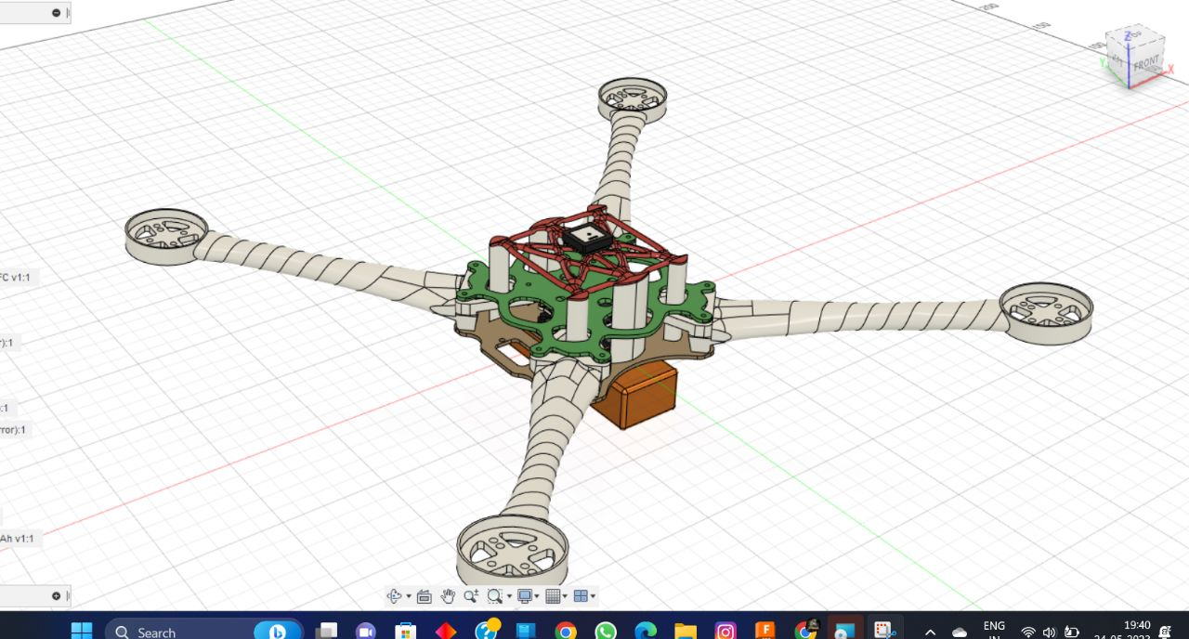

**CAD Model of Drone**

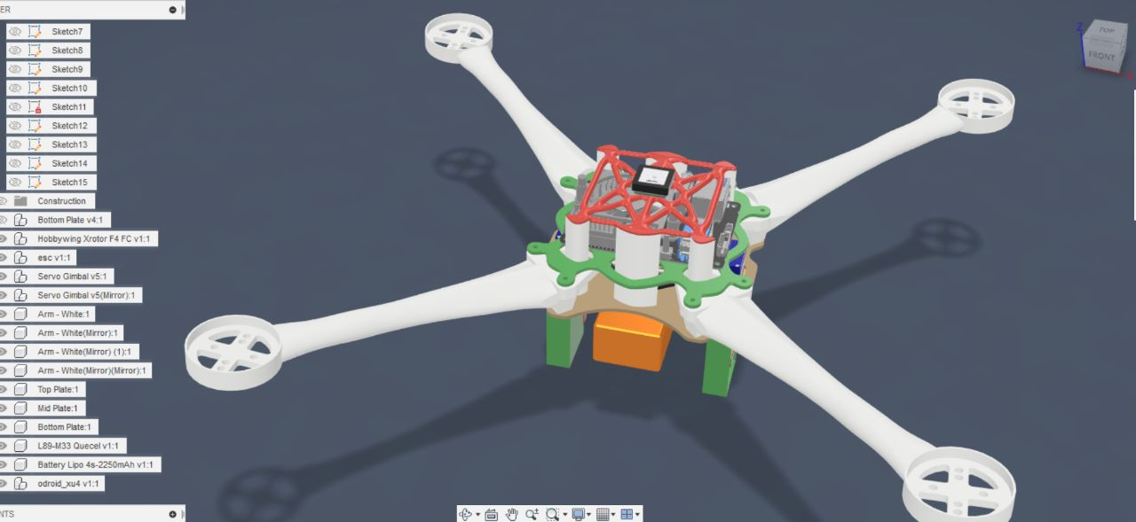

**CAD Model of Drone**

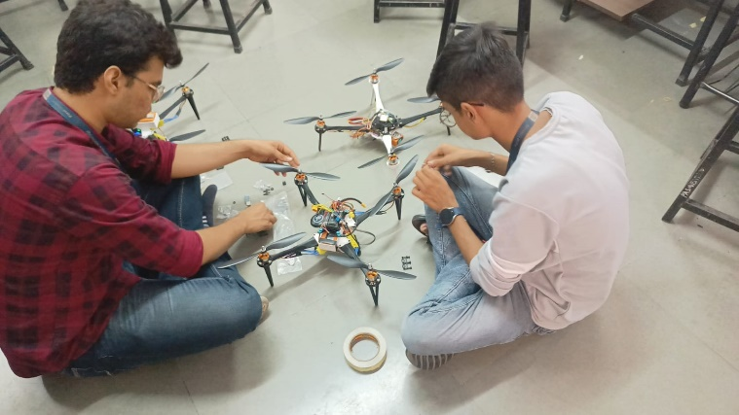

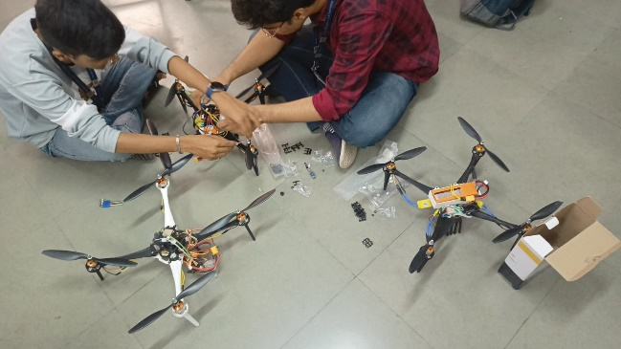

**Robot in Making**

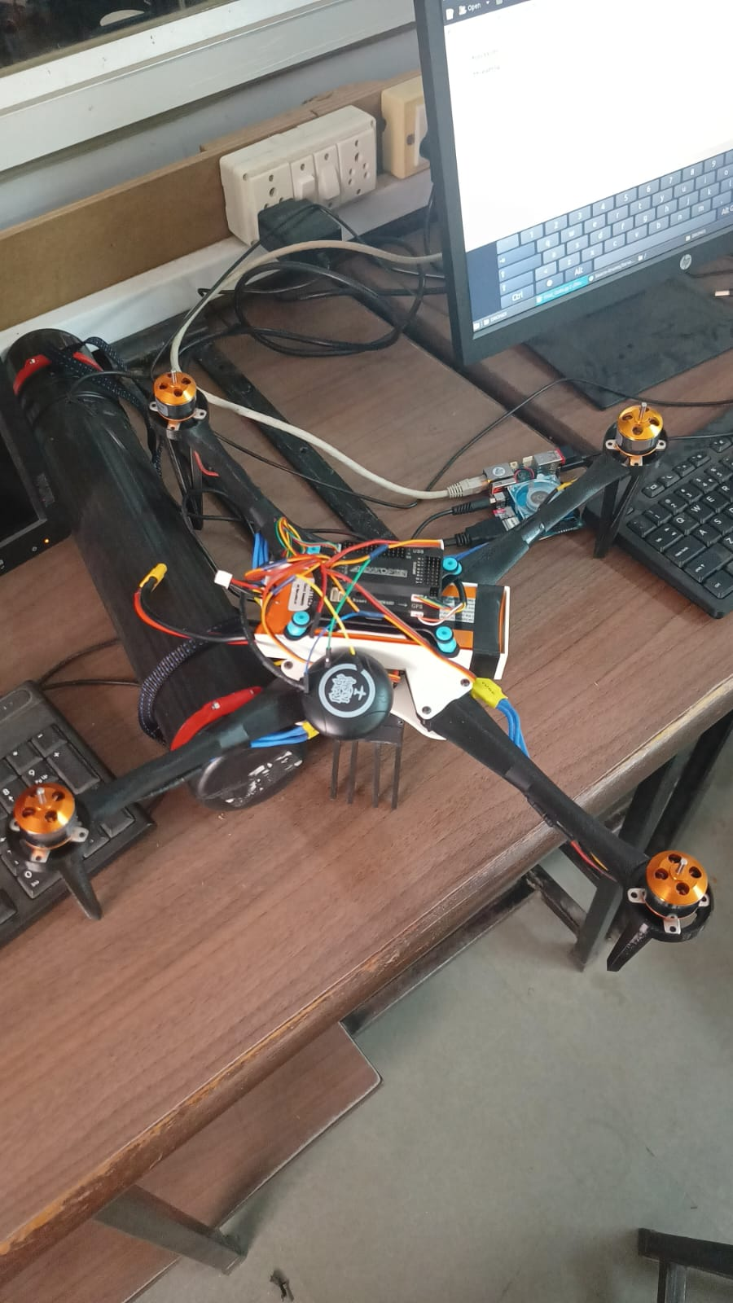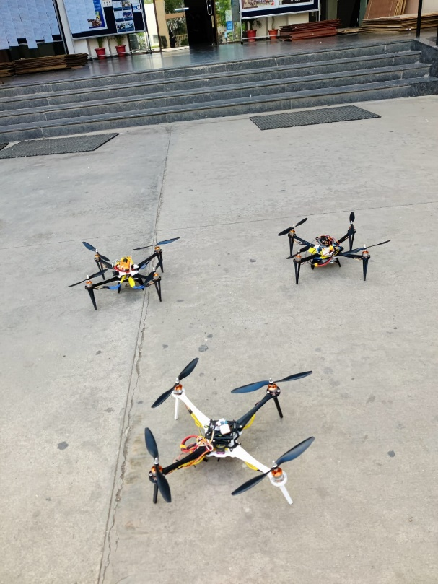

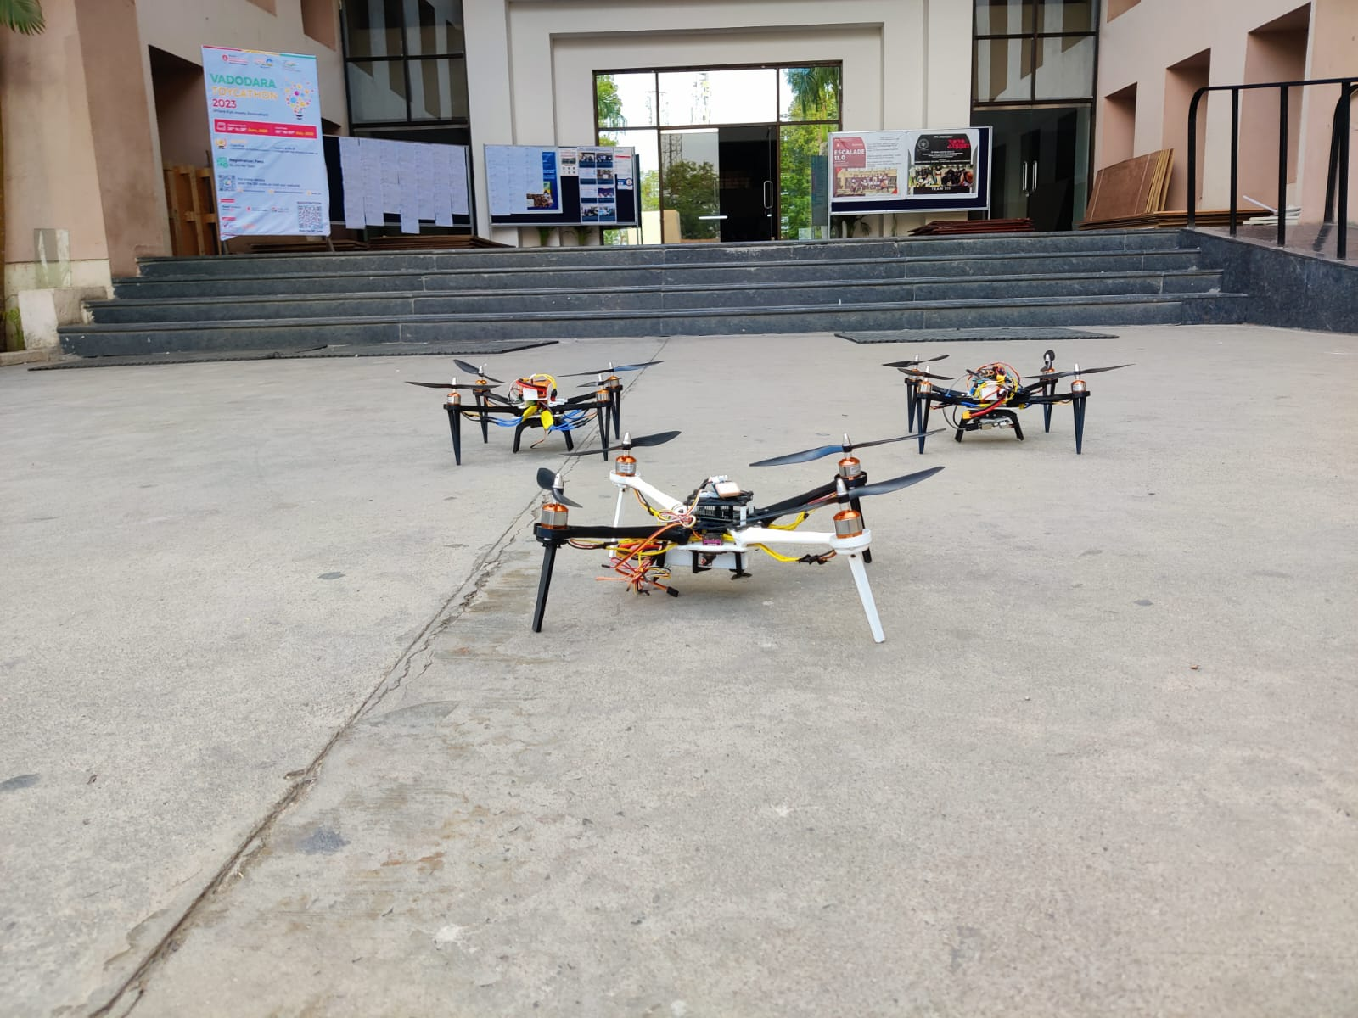

Swarm Robots

1. **Videos (1GB Limit)**

